Development of LIBS instrumentation for steel industry

Yoshihiro Deguchi¹, Taro Yamada¹, Tetsuo H. Sakka², Tommy G. Car ³
¹Graduate School of Advanced Technology and Science, Tokushima University, Tokushima 770-8501, Japan
²Department of Energy and Hydrocarbon Chemistry, Kyoto University, Kyoto 615-8510, Japan
³ Institute of Geology, Ocean University, Hawaii 11110, USA

This is a template of the abstract for LIBS2020. Author(s) will be requested to submit 1-page abstract (pdf file) in English. Use A4 size format and type your text in 10.5-point Times (New) Roman, single-spaced. Figures and Tables may be included in the abstract^{[1]}.
................................................................................................................................................................................................................................................................................................

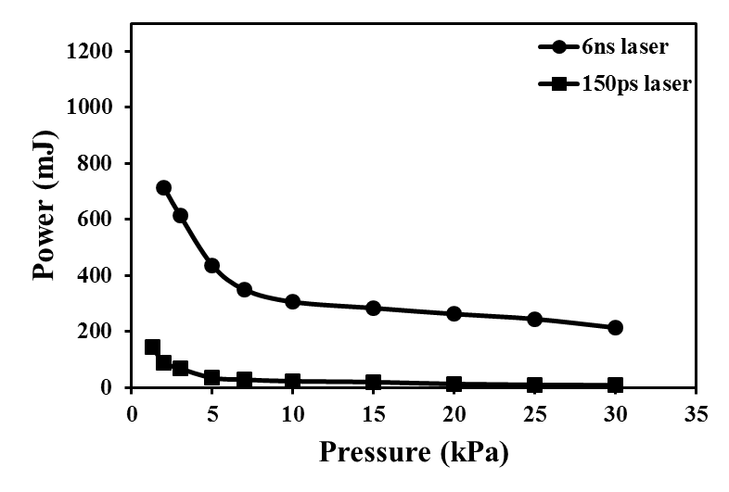
Fig.1 Air plasma generation threshold

References
[1] Y. Deguchi, T.H. Sakka, T. Fujii, I. Wakaida, Application of Laser-Induced Breakdown Spectroscopy, Spectrochim. Acta B 57 (2002) 701-709.
[2] ..........

Please fill the following green part of the table by strictly following the format of the example given in the yellow part.

Details of presenting author and the information for program
Student/Non student
Title (Prof./Dr./Ms./Mr.)
Full name
Email
Name of organization
Country
Presentation preference (oral/poster)
Information for the program (do not forget to underline the presenting author)

Details of presenting author and the information for program (example)
Student/Non student | Non-student
Title (Prof./Dr./Ms./Mr.) | Prof.
Full name | Tetsuo H. Sakka
Email | sakka.tetsuo.2a@kyoto-u.ac.jp
Name of organization | Kyoto University
Country | Japan
Presentation preference (oral/poster) | poster
Information for the program (do not forget to underline the presenting author) | Development of LIBS instrumentation for steel industry, Yoshihiro Deguchi¹, Taro Yamada¹, Tetsuo H. Sakka², Tommy G. Car ³, ¹Graduate School of Advanced Technology and Science, Tokushima University, Tokushima 770-8501, Japan, ²Department of Energy and Hydrocarbon Chemistry, Kyoto University, Kyoto 615-8510, Japan, ³ Institute of Geology, Ocean University, Hawaii 11110, USA

